**SEMINAR REPORT**

**ON**

**PERFORMANCE EVALUATION OF AIVHE, RETINEX AND ADAPTIVE EGDE DETECTION**

**BY**

**NIKHIL JAMDADE**

**SATYAJIT HOSKOTE**

**SHAUNAK DESHMUKH**

**Under the Guidance of**

**Mrs. A. J. VYAVAHARE**

**DEPARTMENT OF ELECTRONICS & TELECOMMUNICATION ENGINEERING**

**P.E.S MODERN COLLEGE OF ENGINEERING**

**PUNE – 411 005.**

**UNIVERSITY OF PUNE**

**2011 - 12**

**Progressive Education Society’s**

**Modern College of Engineering, Pune- 411005**

**CERTIFICATE**

This is to certify that **NIKHIL JAMDADE, SATYAJIT HOSKOTE** and **SHAUNAK DESHMUKH** Of B.E. E&TC have successfully completed the dissertation work titled **‘PERFORMANCE EVALUATION OF AIVHE, RETINEX AND ADAPTIVE EGDE DETECTION’** during the academic year 2011-12.This report is submitted as partial fulfillment of the requirement of degree in B.E. Electronics and Telecommunication (Signal Processing) Engineering of University of Pune.

**Dr. Mrs. K. R. Joshi Prof. Mr. V. N. Patil Mrs. A. J. Vyavahare**

**Principal Head of Department Project Guide**

**ACKNOWLEDGEMENT**

We take this opportunity to express our gratitude to the people who have been instrumental in the successful completion of this project. We wish to express our profound thanks to all those who have helped in making this project a reality. We express our indebtness to Mrs. A. J. Vyavahare for providing us necessary guidelines and facilities to carry out this project work. We are thankful to Dr. Mrs. K. R. Joshi, Principal, P.E.S’S MODERN COLLEGE OF ENGINEERING, for her encouragement. We are also grateful to Prof. Mr. V. N. Patil, (HOD) and Mrs. R. S. Kamthe for aiding us.

**NIKHIL JAMDADE**

**SATYAJIT HOSKOTE**

**SHAUNAK DESHMUKH**

**ABSTRACT**

**PERFORMANCE EVALUATION OF AIVHE, RETINEX AND ADAPTIVE EGDE DETECTION**

Segmentation refers to the process of partitioning a digital image into multiple segments. The goal of segmentation is to simplify and change the representation of an image into something that is more meaningful and easier to analyze. Image segmentation is typically used to locate objects and boundaries (lines, curves, etc.) in images. We usually try to segment regions by identifying common properties. Or, similarly, we identify contours by identifying differences between regions (edges). In this project we are developing adaptive edge detection method which will be more effective than other traditional operator methods. It combines the advantage of the filters to different noises and new contrast image enhancement method, AIVHE (Adaptive Increasingly Value Histogram Equalization Histogram). We are proposing a new algorithm and this algorithm improves the performance of the traditional test edge detection operators and has good segmentation accuracy. We are also applying the preprocessing techniques to obtain better results. The proposed algorithm first filters the noisy images, enhances the contrast of the image by AIVHE method which is then followed by adaptive edge detection. AIVHE is a relatively new method of histogram equalization which has significant improvements as compared to the traditional methods. The input image can produce the effect of contrast enhancement effectively by automatic adaptive increment, the parameter α(k). Edge detection is a fundamental tool in image processing It is an important property of extracting image characteristics in image segmentation, identification and analysis On the basis of analyzing the conventional edge detection algorithm, an adaptive edge-detection method based on the operators not only keeps the operator’s good performance in good detection, good localization effectively control the most noise of the image and only one response to a single edge, but also improves the capability of restraining the fake edge and the automaticity of edge-detection*.*

**TABLE OF CONTENTS**

**Chapter No. Title Page No.**

**ABSTRACT i**

**List of table ii**

**list of figures iii**

**list of symbols iv**

**1. Introduction 1**

**2. Literature Survey/Review 3**

**3. BLOCK DIAGRAM AND DESCRIPTION 17**

**4. SOFTWARE SYSTEM DESIGN 20**

**5. PERFORMANCE AND EXPERIMENTAL RESULTS 29**

**(Algorithms & Flowchart)**

**6. CONCLUSION 32**

**7. REFERENCE / BIBLIOGRAPHY 33**

1. INTRODUCTION

**Image processing** is a method to convert an image into digital form and perform some operations on it, in order to get an enhanced image or to extract some useful information from it. It is a type of signal dispensation in which input is image, like video frame or photograph and output may be image or characteristics associated with that image. Usually **Image Processing** system includes treating images as two dimensional signals while applying already set signal processing methods to them. Digital Image Processing is a rapidly evolving field with growing applications in science and engineering. Pictures are the most common and convenient means of conveying or transmitting information. A picture is worth a thousand words. Pictures concisely convey information about positions, sizes and inter-relationships between objects. They portray spatial information that we can recognize as objects. Human beings are good at deriving information from such images, because of our innate visual and mental abilities. About 75% of the information received by human is in pictorial form. Digital image processing is the use of computer algorithms to perform image processing on digital images. Digital image processing methods stems from three principal application areas:

1. Improvement of pictorial information for human interpretation
2. Processing of image data for efficient storage and transmission.
3. Processing for autonomous machine applications

A fundamental problem of image processing is to effectively remove noise from an image while keeping its features intact. Therefore, it is often desirable to perform some kind of noise reduction on an image. The nature of the problem depends on the type of noise added to the image. Filters can be used for such purpose. Filters are mainly used to suppress either the high frequencies in image i.e. smoothing the image, or the low frequencies i.e. enhancing or detecting edges in image. An image can be filtered in frequency or spatial domain. The frequency domain filters include low pass (Butterworth low pass, Gaussian low pass), High pass (Butterworth high pass and Gaussian high pass) filters. The spatial domain filters include Average, Mean, Median and Adaptive median filters.

Image enhancement processes consist of a collection of techniques that seek to improve the visual appearance of an image or to convert the image to a form better suited for analysis by a human or machine. It means the improvement of an image appearance by increasing dominance of some features or by decreasing ambiguity between different regions of the image. Contrast enhancement is a display technology that improves the exhibition effect by increasing the dynamic range of gray intensity of the input image. We can classify the techniques of contrast enhancement been proposed into two categories: They are Global Enhancement methods and Histogram Equalization based methods. Global Enhancement methods are relatively simple than other methods. The weakness of these methods is that they cannot provide precise image contrast enhancement effect because the inflexibility of these methods and the inability for noise elimination. For Histogram Equalization based methods, the original idea named Histogram Equalization, abbreviated as HE, is very popular for enhancing the contrast of an image. The method performs the remapping in the gray levels to produce uniform distribution in the order of input images. But it is also being criticized that it always causes unacceptable visual artifacts. There are many solutions been proposed to conquer the weakness of the traditional HE method. The three most famous adaptive histogram equalization methods are improving HE methods, spatial processing HE methods and probability density function (PDF) shaping HE methods.

Image Segmentation is one of the most important concerns in digital image processing. It's a long standing problem in computer vision. The objective of the information extraction operations is to replace visual analysis of the image data with quantitative techniques for automating the identification of features in a scene. The edge is not only the basic feature of an image and the important basis for the image segmentation, but also is the important information source of the texture feature and the basis of shape quality analysis. It is the foundation of image segmentation, feature extraction and image understanding. Edge detection refers to the process of identifying and locating sharp discontinuities in an image. The discontinuities are abrupt changes in pixel intensity which characterize boundaries of objects in a scene.



There are many methods for edge detection, but most of them can be grouped into two categories, search-based and zero-crossing based. Edges can be detected using edge detection operators. Operators use first or second order derivative to detect edges within image pixels. There are several operators of edge detection, such as Robert, Sobel, Prewitt, Log, Canny operator and so on.

2. LITERATURE SURVEY-

The purpose of image processing is divided into 5 groups. They are:

1.      Visualization - Observe the objects that are not visible.

2.      Image sharpening and restoration - To create a better image.

3.      Image retrieval - Seek for the image of interest.

4.      Measurement of pattern – Measures various objects in an image.

5.      Image Recognition – Distinguish the objects in an image.

**2.1 GENERAL APPLICATIONS:**

**Intelligent Transportation Systems** –

This technique can be used in Automatic number plate recognition and Traffic sign recognition.

**Remote Sensing** –

Techniques used to interpret the objects and regions are used in flood control, city planning, resource mobilization, agricultural production monitoring, etc.

**Moving object tracking** –

This application enables to measure motion parameters and acquire visual record of the moving object.

**Defense surveillance** –

Aerial surveillance methods are used to continuously keep an eye on the land and oceans. This application is also used to locate the types and formation of naval vessels of the ocean surface.

**Biomedical Imaging techniques** –

For medical diagnosis, different types of imaging tools such as X- ray, Ultrasound, computer aided tomography (CT) etc are used. The diagrams of X- ray, MRI, and computer aided tomography (CT) are given below.

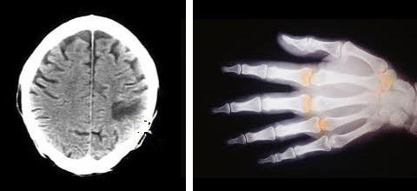

Some of the applications of Biomedical imaging applications are as follows:

Heart disease identification–

To improve the diagnosis of heart diseases, image analysis techniques are employed to radiographic images.

Lung disease identification –

In X- rays, the regions that appear dark contain air while region that appears lighter are solid tissues.

Digital mammograms –

This is used to detect the breast tumor. Mammograms can be analyzed using Image processing techniques such as segmentation, shape analysis, contrast enhancement, feature extraction, etc.

**Automatic Visual Inspection System** –

This application improves the quality and productivity of the product in the industries.   
Automatic inspection of incandescent lamp filaments – This involves examination of the bulb manufacturing process.

Automatic surface inspection systems –

In metal industries it is essential to detect the flaws on the surfaces. Image processing techniques such as texture identification, edge detection, fractal analysis etc are used for the detection.

Faulty component identification –

This application identifies the faulty components in electronic or electromechanical systems. The faulty components can be identified by analyzing the Infra-red images.

2.2 OVERVIEW OF NOISE AND FILTERING METHODS:

Edge detection is difficult in noisy images, since both the noise and the edges contain high frequency tempts to reduce the noise result in blurred and distorted edges. Operators used on noisy images are typically larger in scope, so they can average enough data to discount localized noisy pixels. This results in less accurate localization of the detected edges. Hence for better and efficient segmentation purpose we need to preprocess the image before edge detection.

Noise is any undesirable signal. Noise gets introduced into the data via any electrical system used for storage, transmission, and/or processing. When encountering an image corrupted with noise we have to improve its appearance for a specific application. The techniques applied are application-oriented. Also, the different procedures are related to the types of noise introduced to the image. Some examples of noise are: Gaussian or White, Rayleigh, Shot or Impulse, periodic, sinusoidal or coherent, uncorrelated, and granular. Two noise mod els can adequately represent most noise added to images: Additive Gaussian noise and Impulse noise.

Additive Gaussian noise is characterized by adding to each image pixel a value from a zero-mean Gaussian distribution. Such noise is usually introduced during image acquisition. The zero-mean property of the distribution allows such noise to be removed by locally averaging pixel values. Ideally, removing Gaussian noise would involve smoothing inside the distinct regions of an image without degrading the sharpness of their edges. Classical linear filters, such as the Gaussian filter, smooth noise efficiently but blur edges significantly. Impulse noise is characterized by replacing a portion of an image’s pixel values with random values, leaving the remainder unchanged. Such noise can be introduced due to transmission errors. The most noticeable and least acceptable pixels in the noisy image are then those whose intensities are much different from their neighbors. The Gaussian noise filter cannot adequately remove such noise because they interpret the noise pixels as edges to be preserved. For this reason, separate classes of nonlinear filters have been developed specifically for the removal of impulse noise. The common idea among these filters is to detect the impulse pixels and replace them with estimated values, while leaving the remaining pixels unchanged. When applied to images corrupted with Gaussian noise, however, such filters are not effective, and in practice leave grainy, visually disappointing results. Not much work has been carried out on building filters that can effectively remove both Gaussian and impulse noise, or any mixture. Such “mixed noise” could occur, for instance, when sending an already noisy image over faulty communication lines.

FILTERS:

2.2.1 BUTTERWORTH FILTER

A high pass filter is the one which allows the high frequency components to pass and attenuates the lower frequency components.

H ( u , v) = 0 D ( u , v ) <= D0

= 1 D ( u , v ) > D0

where D0 is the cut-off frequency.

Image lines and image edges or high frequency components in the spectrum correspond; therefore, we can use high-pass filtering method to suppress low frequency components, so as to achieve enhanced high frequency components, so that the edge of the image becomes clear. Commonly used high-pass filter are: the ideal high-pass filter, Butterworth high-pass filter, exponential high-pass filter. The frequency response of an ideal high pass filter is very abrupt. This causes ringing effect. Ideal high-pass filter filtering will also produce a large number of noise points. Index of the ideal high-pass filter high-pass filter is relatively better, but still too steep cut-off part, this is only the high-pass filtered by difficult to detect, but after treatment Sobel operator will generate a lot of noise points The Butterworth filter is relatively smooth, controlled by the order of the shape of the curve. Butterworth filter transfer function is:

H( u , v ) = 1 / { 1+ [ D0 / D( u , v ) ] 2n }

where D0 is the cut-off frequency.

‘n’ controls the shape, which determines the Function of the decay rate. Between high and low frequencies due to the relatively smooth transition, so, Butterworth filter of the output map the ringing effect is not obvious. To this end, pre-processing using Butterworth high-pass filter is more suitable. The frequency response of a Butterworth filter is smooth. So there is no ringing.

2.2.2 MEDIAN FILTER:

The median filter is a nonlinear image processing technology based on statistical theory which can effectively suppress noise.

This class of filter belongs to the class of edge preserving smoothing filters which are non-linear filters. This means that for two images A(x) and B(x):

Median [A(x) + B(x)] ≠ median[A(x)]+median[B(x)]

The effect of the median filter to the noise depends on two related but entirely separate elements: the scope for neighbourhood and median number of pixels involved in the calculations. Relatively simple situation is a square template N X N (N here are often odd), calculation formula used in all the points. These filters smooth the data while keeping the small and sharp details. The median is just the middle value of all the values of the pixels in the neighbourhood. It is not the same as average (or mean), instead, the median has half the values in the neighbourhood larger and half smaller. The median is a stronger "central indicator" than the average. In particular, the median is hardly affected by a small number of discrepant values among the pixels in the neighbourhood. Consequently, median filtering is very effective at removing various kinds of noise. Median filter convolution calculation generally is slower than convolution. Because it needs all the pixels in the domain of the neighbourhood dark gray-scale sequencing. And similar compared to the low-pass linear filters, median filters can be used in the attenuation of random noise at the same time without losing boundaries blurred and therefore to be welcomed. Consequently, median filtering is very effective at removing various kinds of noise.

Like the [mean filter](http://www.dai.ed.ac.uk/HIPR2/mean.htm), the median filter considers each pixel in the image in turn and looks at its nearby neighbors to decide whether or not it is representative of its surroundings. Instead of simply replacing the pixel value with the mean of neighboring pixel values, it replaces it with the median of those values. The median is calculated by first sorting all the pixel values from the surrounding neighborhood into numerical order and then replacing the pixel being considered with the middle pixel value.

The Disadvantage of Median filter :

Although median filter is a useful non-linear image smoothing and enhancement technique, it also has some disadvantages. The median filter removes both the noise and the fine detail since it can't tell the difference between the two. Anything relatively small in size compared to the size of the neighborhood will have minimal affect on the value of the median, and will be filtered out. In other words, the median filter can't distinguish fine detail from noise.

2.2.3 ADAPTIVE MEDIAN FILTER-

As an advanced method compared with standard median filtering, the Adaptive Median Filter performs spatial processing to preserve detail and smooth non-impulsive noise. A prime benefit to this adaptive approach to median filtering is that repeated applications of this Adaptive Median Filter do not erode away edges or other small structure in the image.

2.3 OVERVIEW OF CONTRAST ENHANCEMENT BASED ON HISTOGRAM EQUALIZATION:

For Histogram Equalization based methods, the original idea named Histogram Equalization, abbreviated as HE, is very popular for enhancing the contrast of an image. The method performs the remapping in the gray levels to produce uniform distribution in the order of input images. But it is also being criticized that it always causes unacceptable visual artifacts. There are many solutions been proposed to conquer the weakness of the traditional HE method. The three most famous adaptive histogram equalization methods are improving HE methods, spatial processing HE methods and probability density function (PDF) shaping HE methods. In order to improving HE methods, the input histogram is divided into two sub-histograms based on the mean brightness, then the two sub-histograms are manipulated by HE individually. For providing a well designed adaptive contrast enhancement effectively and prevent a significant change of gray levels, our project focuses on the PDF shaping HE techniques to propose a simple contrast enhancement scheme named "Adaptively Increasing the Value of Histogram", abbreviated as AIVHE, to enhance the contrast in a more efficient way. Histogram equalization is a specific case of the more general class of histogram remapping methods. These methods seek to adjust the image to make it easier to analyze or improve visual quality.

2.3.1 SOME POPULAR TECHNIQUES ABOUT IMAGE ENHANCEMENT:

2.3.1.1 TRADITIONAL HE METHOD-

HE obtains input-output transfer function by means of the histogram of input images. For the digital image input f(x, y) in an active area of gray level [0, L-1] with N pixels. The

probability density function (PDF) P(k) of the image is defined as (1), where L is the maximum gray level of image:



In the equation, nk is the total number of pixels in the image with gray level k.

Cumulative density function (CDF):



Input-output transfer function :



where X0 and X L-1 are the minimum and maximum luminance values.

**Although the transfer function can derive enhanced images by contrast enhancement, HE cannot control the effect of enhancement. Moreover, while histogram is centralized in a narrow area, the method tends to produce undesirable artifacts.**

2.3.1.2 ADAPTIVE HISTOGRAM EQUALIZATION-

**Adaptive histogram equalization is a computer**[**image processing**](http://en.wikipedia.org/wiki/Image_processing)**technique used to improve  contrast in images. It differs from ordinary**[**histogram equalization**](http://en.wikipedia.org/wiki/Histogram_equalization)**in the respect that the adaptive method computes several**[**histograms**](http://en.wikipedia.org/wiki/Histogram)**, each corresponding to a distinct section of the image, and uses them to redistribute the lightness values of the image. Ordinary histogram equalization simply uses a single histogram for an entire image. Adaptive histogram equalization is considered an image enhancement technique capable of improving an image's local contrast, bringing out more detail in the image. However, it also can produce significant**[**noise**](http://en.wikipedia.org/wiki/Signal_noise)**. A generalization of adaptive histogram equalization called contrast limited adaptive histogram equalization, also known as**[**CLAHE**](http://en.wikipedia.org/wiki/CLAHE)**, was developed to address the problem of noise amplification.**

CLAHE:

In [Image Processing](http://en.wikipedia.org/wiki/Image_Processing), CLAHE stands for Contrast Limited Adaptive Histogram Equalization. CLAHE is a technique used to improve the local [contrast](http://en.wikipedia.org/wiki/Contrast_(vision)) of an image. It is a generalization of [adaptive histogram equalization](http://en.wikipedia.org/wiki/Adaptive_histogram_equalization) and ordinary [histogram equalization](http://en.wikipedia.org/wiki/Histogram_equalization).

2.3.1.3 AIVHE-

Contrast enhancement is a display technology that improves the exhibition effect by increasing the dynamic range of gray intensity of the input image. The technologies for image contrast enhancement are improved evidently since the popularity of consumer electronics and image processing in the last decade. Adaptive histogram equalization is a computer image processing technique used to improve contrast in images. AIVHE offers a gradually increment by the mean brightness of the image to modify the original probability density function (PDF). It also provides a mechanism of adjustment to contrast enhancement by means of adaptive constraint parameter α(k) for adjustment automatically, which is determined by the initial value γ and user defined parameter β. The method can obtain more gray level distribution of dark and bright regions and also increase gray levels effectively. AIVHE can not only provide natural image contrast enhancement effect, but also enhance display quality, further prevent from produce excess strengthen or artifacts for image output.

2.3.1.4 RETINEX:

A fundamental concern in the development of resilient, vision-based, automation technology is the impact of wide-ranging extraneous lighting and exposure variations on the acquired imagery. This concern can be considerably ameliorated by the application of the (MSR) image-enhancement algorithm. The MSR is a non-linear, context-dependent enhancement algorithm that provides color-constancy, dynamic range compression and sharpening

2.3 EDGE DETECTION

Edges, which are one of the important features of image, are areas with strong contrasts and a jump in intensity from one pixel to the next. Edge detection is a fundamental tool in image processing and computer vision, particularly in the areas of feature detection and feature extraction, which aim at identifying points in a digital image at which the image brightness changes sharply or, more formally, has discontinuities. Edge detection can reduce the amount of data, filter out useless information and preserve the important structural properties in an image. It is the foundation of image segmentation, feature extraction and image understanding. Edges are places in the image with strong intensity contrast. Edges often occur at image locations representing object boundaries. Representing an image by its edges has the further advantage that the amount of data is reduced significantly while retaining most of the image information. So edge detection is a fundamental tool used in most image processing applications to obtain information from the frames as a precursor step to feature extraction and object segmentation.

Figures show general idea of edge detection.

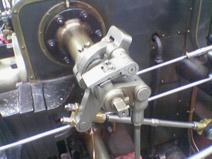 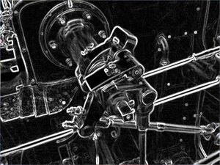

The purpose of detecting sharp changes in image brightness is to capture important events and changes in properties of the world. It can be shown that under rather general assumptions for an image formation model, discontinuities in image brightness are likely to correspond to

* Discontinuities in depth,
* Discontinuities in surface orientation,
* Changes in material properties and
* Variations in scene illumination.

In the ideal case, the result of applying an edge detector to an image may lead to a set of connected curves that indicate the boundaries of objects, the boundaries of surface markings as well as curves that correspond to discontinuities in surface orientation. Thus, applying an edge detection algorithm to an image may significantly reduce the amount of data to be processed and may therefore filter out information that may be regarded as less relevant, while preserving the important structural properties of an image. If the edge detection step is successful, the subsequent task of interpreting the information contents in the original image may therefore be substantially simplified. However, it is not always possible to obtain such ideal edges from real life images of moderate complexity. Edges extracted from non-trivial images are often hampered by fragmentation, meaning that the edge curves are not connected, missing edge segments as well as false edges not corresponding to interesting phenomena in the image – thus complicating the subsequent task of interpreting the image data. Edge detection must be efficient and reliable because the validity, efficiency and possibility of the completion of subsequent processing stages rely on it. To fulfill this requirement, edge detection provides all significant information about the image. For this purpose, image derivatives are computed. However, differentiation of an image is an ill-posed problem; image derivatives are sensitive to various sources of noise, i.e., electronic, semantic, and discretization / quantification effects. To regularize the differentiation, the image must be smoothed. However, there are undesirable effects associated with smoothing, i.e., loss of information and displacement of prominent structures in the image plane. Furthermore, the properties of commonly-used differentiation operators are different and therefore they generate different edges. It is difficult to design a general edge detection algorithm which performs well in many contexts and captures the requirements of subsequent processing stages. Consequently, over the history of digital image processing a variety of edge detectors have been devised which differ in their purpose and their

mathematical and algorithmic properties. There are many methods for edge detection, but most of them can be grouped into two categories, search-based and zero-crossing based. The search-based methods detect edges by first computing a measure of edge strength, usually a first-order derivative expression such as the gradient magnitude, and then searching for local directional maxima of the gradient magnitude using a computed estimate of the local orientation of the edge, usually the gradient direction.

There are several operators of edge detection, such as: Robert, Sobel, Prewitt, LOG, Canny operator.

Some Advantages and Disadvantages of Edge Detectors:

|  |  |  |
| --- | --- | --- |
| Operator | Advantages | Disadvantages |
| Classical (Sobel,  prewitt…) | Simplicity, Detection of edges and their orientations | Sensitivity to noise, Inaccurate |
| Zero Crossing (Laplacian, Second directional derivative) | Detection of edges and their  orientations. Having fixed  characteristics in all directions | Responding to some of the  existing edges, Sensitivity to  noise |
| Laplacian of Gaussian (LoG) (Marr-Hildreth) | Finding the correct places of  edges, Testing wider area  around the pixel | Malfunctioning at the corners,  curves and where the gray  level intensity function varies.  Not finding the orientation of  edge because of using the Laplacian filter |
| Canny | Using probability for finding error rate, Localization and  response. Improving signal  to noise ratio, Better detection  specially in noise conditions | Complex Computations,  False zero crossing, Time  consuming |

2.3.1 PERFORMANCE AND COMPARISONS:

2.3.1.1 SOBEL OPERATOR BASED ON BUTTERWORTH FILTERING

There are many isolated edge pixels; but Sobel operator on the edge of the positioning is not very accurate, the border width of the image is often more than one pixel. Figure 6 can be seen, the Butterworth high-pass filter processing, then the image obtained by Sobel operator edge map, on the edge of the positioning more accurate, the boundary line is not very thick, and the noise is not Less sensitive.

  

Original Image Result of Sobel operator. Sobel edge detection on

Butterworth filter

From the above figures we can conclude:

(1) Edge detection does not pixel based only on the current point mutations, but also according to their neighbourhood and its gradient to determine the pixel, otherwise it will produce false positives.

(2) In some of the noise-sensitive positioning allowed the operator to pre-process the image before processing can be improved to some extent, good or even accurate positioning edge.

(3) Low filter cut-off frequency will affect the performance, and high cut-off frequency will result in some marginal loss.

(4) In the image pre-processing, you must select the appropriate parameters. Filter function is too steep will bring a lot of image noise, edge detection after a serious disturbance; and too smooth function is limited to the low frequency filter, the edge of the high frequency part will affect.

2.3.1.2 THE SOBEL OPERATOR BASED ON MEDIAN FILTERING:

This paper combines the Sobel operator and median filtering, and this technique can effectively remove the salt and pepper noise in the image. The reason is that median filtering has a fine result when filtering out jump signal. The stochastic signal of salt and pepper noise is caused by the mutation of continuous signal, so the combine between this method and Sobel operator can better extract the edge of the image with salt and pepper noise signal. The process is:

• According to the consistency of noise to select a right median filter template.

• Make median filter on the image, and filter out salt and pepper noise.

• By the template of Sobel operator in image 1 to user defined the edge template coefficient.

• After the Sobel edge detect operator be given, for every pixel of the image, to make convolution with the template, and get the gradient of the point. The amplitude of the gradient is the output of this point. And at last we get the edge detect image.

From the figures we can conclude:

Use of median filter prior to edge detection removes Salt and pepper noise in images and it effectively overcome the problem that the Sobel operator is only sensitive to vertical and horizontal direction. The effect of combination of the median filter and Sobel operator to remove salt-pepper noise is better than the classical edge detection method.

  

Lena image with salt and pepper noise Sobel edge detection operator Sobel operator based on

without filtering median filter

2.3.1.3 EXPERIMENTAL RESULTS AND COMPARISION:

As shown in Figures, Robert operator is sensitive to noise and misses a lot of edge information which leads to broken up edges. Therefore, Robert operator is not suitable to detect the image with complex background and massive noise. Sobel and Prewitt operator has certain ability to suppress the noise, but still loses some of edge information. Log operator can detect continuous edges, but it is very sensitive to noise because that it is the second derivative operator. If we choose appropriate parameter to eliminate the noise, the edge localization ability is weakened.

  

Original image Robert operator Sobel operator

  

Prewitt operator LOG operator Canny operator

As shown in Figures, Robert operator is sensitive to noise and misses a lot of edge information which leads to broken up edges. Therefore, Robert operator is not suitable to detect the image with complex background and massive noise. Sobel and Prewitt operator has certain ability to suppress the noise, but still loses some of edge information. Log operator can detect continuous edges, but it is very sensitive to noise because that it is the second derivative operator. If we choose appropriate parameter to eliminate the noise, the edge localization ability is weakened.

 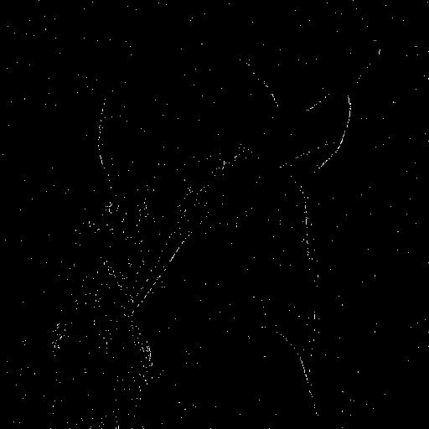 

Original image Robert operator Sobel operator

 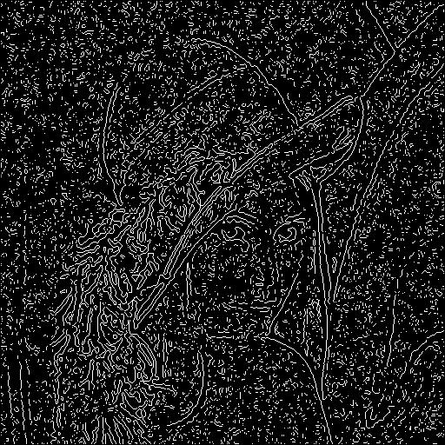 

Prewitt operator LOG operator Canny operator

We can see from the above picture, the image with Gaussian white noise, When the classical edge detection operator against the image with Gaussian white noise on the edge detection, the noise points of the image have also been detected, meanwhile the image edge is not clear. In particular the Canny operator, Sobel operator and the Laplacian operator in a certain degree, change the contrast of the image, and edge detection is also not clear enough. Compared to other operators for the Prewitt operators detect the image with the Gaussian white noise, the effect of image edge detection more obvious. However, due to the traditional edge detection operator noise smoothing ability and ability to locate the edge of the existence of contradictory, In order to overcome this deficiency, The best way is to de-noising effect of a number of obvious ways to mix with those operators, can effectively filter out the noise can also try to keep the edge of the image details, while the role of traditional edge detection operator characteristics.

3. BLOCK DIAGRAM AND DESCRIPTION:

(Smoothness Coefficient)

Image Enhancement Filtering Methods (If nosy input image)

Contrast enhancement techniques

Adaptive Edge detection

Input

image Output Image

3.1 ADAPTIVE MEDIAN FILTERING:

The Adaptive Median Filter performs spatial processing to determine which pixels in an image have been affected by impulse noise. Therefore the adaptive median filtering has been applied widely as an advanced method compared with standard median filtering The Adaptive Median Filter classifies pixels as noise by comparing each pixel in the image to its surrounding neighbour pixels. The size of the neighbourhood is adjustable, as well as the threshold for the comparison. A pixel that is different from a majority of its neighbours, as well as being not structurally aligned with those pixels to which it is similar, is labeled as impulse noise. These noise pixels are then replaced by the median pixel value of the pixels in the neighbourhood that have passed the noise labeling test.

Its purpose:

1) Remove impulse noise

2) Smoothing of other noise

3) Reduce distortion, like excessive thinning or thickening of object boundaries

Advantages:

The standard median filter does not perform well when impulse noise is Greater than 0.2, while the adaptive median filter can better handle these noises.

The adaptive median filter preserves detail and smooth non-impulsive noise, while the standard median filter does not.

3.2 ADAPTIVELY INCREASING VALUE OF HISTOGRAM EQUALIZATION (AIVHE):

Based on PDF shaping HE methods, this study proposes a new contrast enhancement method, abbreviated as AIVHE. The method reshapes the original PDF to obtain new PDF to prevent a significant change in the gray levels. It also provides a mechanism of adjustment to contrast enhancement by means of adaptive constraint parameter α(k) for adjustment automatically, which is determined by the initial value γ and user defined parameter β. AIVHE divides the original PDF into upper and lower blocks on the basis of Pbas. A value of maximum threshold Ph is then be set to restrict the variation of the PAIVHE(k), and then limit the value of PAIVHE(k) be not greater than Ph. AIVHE reshapes original PDF and obtain the PAIVHE(k).The value of Pbas in the equation is set as the average PDF (normalized total number of pixels divided by maximum gray level, 1 / L). The value can prevent output from unnecessary effect. The value of threshold, Ph, is set as double of Pbas to divide PAIVHE(k) into two equal areas to obtain effective image contrast enhancement effect. The value of weight parameter, β, is defined to adjust the enhance effect by user. The β is a real number in the range of [0, 1]. The function of HE is produced when the value of β is set by zero and Pbas is the mean value of the maximum and the minimum values of P(k). The effect of contrast enhancement will be decreased by increasing the value of β. The adaptive constraint parameter α(k) is tuned automatically based on the mean brightness Xm to increment the value to mean brightness gradually. It changes each gray region for pixel distribution proportion of steps, and produces input-output transfer function based on mean brightness to obtain more output pixels to distribute to dark and bright regions. The initial value γ is a real number in the range of [0, 1]. By setting the initial value γ for α(k), the pixel distribution of PDF in the dark region and bright region is decided. For instance, by setting the initial value γ of α(k) to zero will produce black and white stretching effects in both regions. On the other hand, the number of pixels will be increased in the mean brightness by increasing the value to produce a smooth input-output transfer curve. To determine the optimum value of β and γ, we are going to determine a constant β and γ that can produce natural contrast enhancement result when input image is low contrast and can prevent to produce over enhancement result when input image is high contrast. The value of β is set to small real number that can produce desirable contrast enhancement result and we set the value of γ to small real number that can produce natural histogram distribution result. By adopting various values for β and γ to identify the effect of the parameter, the final simulation results show that the both adequate values of β and γ are 0.35. The initial values will produce most clear images in most cases. AIVHE control dark and bright regions stretching degree of the image by γ of α(k), and control the degree of whole contrast enhancement effect of the image by β. By the PAIVHE(k), the cumulative density function, CAIVHE(k),is straight forward accumulated. Since the accumulation of CAIVHE(k) does not amount to 1, we have to normalize CAIVHE(k) to gray level [0, L-1] and then using CAIVHE(k) output the image is obtained. [4]

3.3 RETINEX:

Human perception excels at constructing a visual representation with colour and detail across wide ranging photometric levels caused by lighting variations. In addition human vision computes colour so as to be relatively independent of spectral variations in illumination. The images obtained with film and electronic cameras suffer, by comparison, from loss in clarity of detail and colour as light levels drop within shadows, or as distance from a lighting source increases. When the dynamic range of a scene exceeds the camera’s dynamic range, there can be irrevocable loss of visual information at both extremes of the scene dynamic range. Improved fidelity of colour images to human observation should, therefore, combine dynamic range compression, colour constancy, and colour and lightness rendition. The Multi scale Retinex (MSRCR) achieves all these goals.

The idea of the Retinex was conceived by Land as a model of the lightness and color perception of human vision. In our project, we use it as a platform for digital image enhancement by synthesizing local contrast improvement, colour constancy, and lightness/colour rendition. The intent is to transform the visual characteristics of the recorded digital image so that the rendition of the transformed image approaches that of the direct observation of scenes. Retinex uses the Gaussian surround function. Since the width of the surround affects the rendition of the processed image, multiple scale surrounds are necessary to provide a visually acceptable balance between dynamic range compression and graceful tonal rendition. The final visual defect in performance is the colour graying due to global and regional violations of the gray world assumption intrinsic to Retinex theory. A colour restoration is essential for correcting this and takes the form of a log spectraloperation similar to the log spatialoperation of the center/surround. This produces an interaction between spatial and spectral processing and results in a trade-off between strength of color constancy and color rendition. The colour restoration yields a modest relaxation in color constancy, perhaps comparable to human color vision’s perceptual performance. The images either have saturated bright regions to compensate for the dark regions, or clipped dark regions to compensate for the bright regions. Even when the dynamic range of the scene is narrow enough to be completely captured by the dynamic range of the imaging device, the resultant image is a poor representation of the observed scene, being too dark and too low in overall contrast. A nonlinear representation, such as the multi scale Retinex with color restoration (MSRCR) provides the necessary dynamic range compression that encompasses the full dynamic range of the scene that is needed to produce images that approach the direct perception of natural scenes.

The basic form of the multi scale Retinex (MSR) is given by



Where,

Ii is the ith spectral band of the N-band input image,

Ri is the corresponding is the Retinex output,

‘*’ represents the (circular) convolution operator,

F is a (Gaussian) surround function, and

K is the number of the scales.

The Gaussian surround function is given by:



The σk are scale parameters that control the performance of the single scale Retinex (SSR): small σk lead to SSR outputs that contain the fine features in the image at the cost of colour, and large σk lead to outputs that contain colour information, but not fine detail.

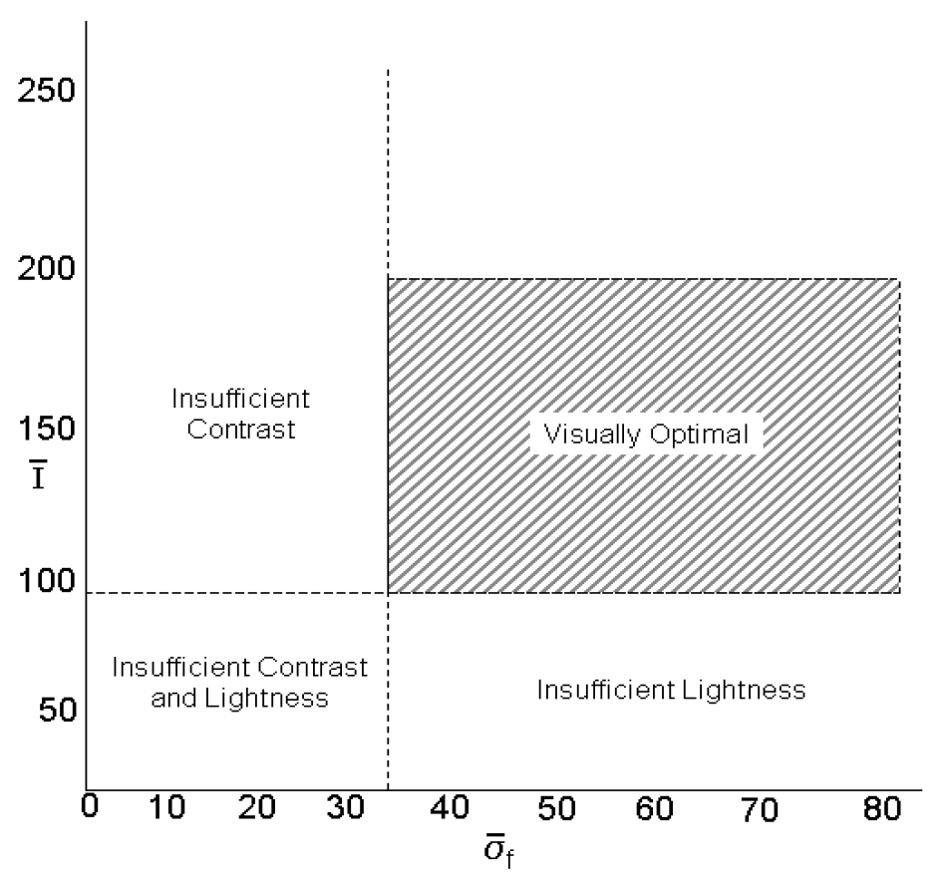

**Mean vs Standard Deviation Graph for optimal visual range for contrast enhancement**

Above Figure 8 represents good contrast quality and optimal visuality range with help of statistical parameters mean and standard deviation. Images having mean between 100 to 200 with standard deviation in range 33 to 80 are optimally visual.In elsewhere region images are with some insufficient contrast and lightness.

# Smoothing coefficient:

The degree of smoothness of an image depends upon the amount of energy in the high frequencies. Hence, the smoothness can be quantified by using measuring the energy in the image at high frequencies. The smoothness coefficient is given by the following equation:



Where, Ť is the discrete Fourier transform of the M1 ×M2 input image, and G is a high-pass filter given by



The smoothness coefficient, S, represents the reciprocal of the amount of energy in the high-pass filtered version of the input image, I: the higher the amount of energy, the more the high frequency information. Since, the high-frequency information is directly correlated to the fine details in an image, the smoother an image the larger the S.

3.4 SUSAN EDGE DETECTION:

After the preprocessing stage (if required), the next step is to perform the edge detection. Edge detection is used because it is the basic low level primitive for image processing which conveys the structural information about the structures in the image. Edge detection performs the filtering operation to reduce the amount of data in the image by removing the irrelevant information and preserving the structural information in the image. There are many edge detection operators like Canny, Sobel, Marr-Hildreth, that are widely used which have their own drawbacks. Some of the drawbacks are poor connectivity at the edges and the corners being rounded. Also, with the increase in the Gaussian filter, there is a decrease in the noise levels at the expense of accuracy in localization of edges. We have resorted to the SUSAN edge detection operator, a non-linear filtering operator, which is above the drawbacks of most of the other edge detection operators. The main idea of the SUSAN edge detection operator is to associate a small area of neighboring pixels with similar brightness to a center pixel. This small area of pixels with similar brightness is termed as USAN, which is an acronym for Univalue Segment Assimilating Nucleus. This phenomenon of associating each point in the image with an area of pixels with similar brightness is the basis for the SUSAN principle. The USAN contains lot of information about the structure of the image which is effectively region finding on a small scale. From the size, centroid and the axis of symmetry of the USAN, the edges and two dimensional features can be detected. The acronym SUSAN (Smallest Univalue Segment Assimilating Nucleus) comes from the principle which states that, an image processed to give as output inverted USAN area has edges and two dimensional features strongly enhanced, with the two dimensional features more strongly enhanced than edges. The SUSAN edge detection algorithm is implemented using circular masks of 37 pixels (radius of 3.4 pixels).

The mask is as follows:

Mask=

This mask is placed at each pixel in the image and the brightness of each pixel in the mask is compared with the nucleus using the following equation:



where ~r0 is the position of the center pixel, ~r is the position of neighboring pixels in the mask in the two dimensional image, I(~r0) is the intensity of the nucleus, I(~r) is the intensity of other pixels in the mask and t is the threshold. The parameter *t* is used to determine the minimum contrast of features and maximum amount of noise to be ignored. For a foggy image, the value of *t* is smaller when compared to that of a clear image because the foggy images have lower contrast. The number of pixels in the USAN is counted as follows:



After finding the value of n, it is compared with the geometric threshold:



where the geometric threshold (g) is set to 3nmax/4 for optimal noise rejection with nmax being the number of pixels in the mask and R(~r0), the initial edge response. The algorithm gives pretty good results, but a much more stable equation which is smoother version of Equation 8 is as follows:



3.3 ADAPTIVE EDGE DETECTION:

There are many methods by which adaptive edge detection can be done in different ways.

Some of them are shortlisted as below:

An Adaptive Edge-detection Method Based on the Canny Operator-

This method not only keeps the Canny’s good performance in good detection, good localization and only one response to a single edge, but also improves the capability of restraining the fake edge and the automaticity of edge-detection based on the Otsu’s thresholding method.

An Adaptive Edge-detection Method Based on the Canny Operator-

This method not only keeps the Canny’s good performance in good detection, good localization and only one response to a single edge, but also improves the capability of restraining the fake edge. This uses concativity analysis for automatically finding threshold values for edge-detection.

A Self-Adaptive Edge Detection Method Based on LoG Algorithm-

In order to avoid the defects of the LoG operator, the paper based on the date of experimentation and the Matlab software elicits the relation between the entropy of the gray level co occurrence matrix and the Gaussian space coefficient. Optimum Gaussian space coefficient of LoG operator can be self-adaptive acquired based on the entropy of the image.

4. SOFTWARE SYSTEM DESIGN

4.1 ADAPTIVE MEDIAN FILTER

NOTATION:

Vmin = minimum gray level value in Sxy ;

Vmax = maximum gray level value in Sxy

Vmed = median of gray levels in Sxy ;

Vxy = gray level at coordinates (x, y)

Smax = maximum allowed size of Sxy

ALGORITHM:

Level A:

i. A1 = Vmed - Vmin

ii. A2 = Vmed - Vmax

iii. If A1 > 0 AND A2 < 0, go to level B

iv. else increase the window size

v. if window size < Smax, repeat level A

vi. else output Vxy

Level B:

i. B1 = Vxy - Vmin

ii. B2 = Vxy - Vmax

iii. if B1 > 0 AND B2 < 0, output Vxy

iv. else output Vmed





4.2 AIVHE

ALGORITHM

1. Read the input image specified by the user.
2. Determine dimensions of the image. Take m=length, n=width and q=3 (for colour images).
3. Compute the maximum intensity level present in that image. This is required for future calculations.
4. Create an array b() of size 1*L, calculate the number of pixels of intensity k and store it in b(k).
5. Using b(k) we can plot the original PDF (p) of the image.
6. Now define 2 new parameters Pbas and Ph and set them as Pbas = mean(p); Ph = 2*Pbas.
7. Find out the mean brightness (Xm) of image.
8. Accept the values of β and γ from the user.
9. From the values of Xm, β and γ find out the value of α(k) using the following formulas:  
   α (k)=((1-((Xm-k)/Xm))2)*(1- γ)+ γ ; 1 < k < Xm  
     
   α (k)=((1-((k-Xm)/((l-L)-Xm)))2)*(1- γ)+ γ; Xm+1 < k < L
10. Using the value of this adaptive parameter α, find out the new modified PDF PAIVHE using the following formulas:  
      
    PAIVHE(k) = Ph ; p(k) >= Ph  
    PAIVHE(k) = p(k) - ( α(k)*( p(k) - Pbas)*β); Pbas < p(k) < PhPAIVHE(k) = p(k) + ( α(k)*(Pbas-p(k))*β); p(k) <= PbasNow calculate the CDF (cumulative distribution function) of PAIVHE and store it in a new array C().
11. Calculate the transfer function ‘f’ using formula :  
    f(i) = (L-1) * ( C(i) / C(L-1) )
12. Apply this new transfer function on the original image to obtain the new histogram equalized image.











4.3 MULTI SCALE RETINEX WITH COLOUR RESTORATION

ALGORITHM

1. Read the input image.
2. Input the number of scales K and values of σk corresponding to the scales.
3. Now create a Gaussian surround function for each value of σ.

fk(x1, x2) = akGk(x1, x2)

Gk(x1, x2) = exp (−(x12 + x22)/σk2

1. Normalize the surround functions.

Fk(x, y) = fk(x, y)/∑fk(x, y)

1. Apply Multi Scale Retinex.

Ii is the ith spectral band of the N-band input image,

Ri is the corresponding is the Retinex output,

‘*’ represents the (circular) convolution operator,

F is a (Gaussian) surround function, and

K is the number of the scale

WK is the weight corresponding to each scale.

1. Now create a colour restoration function.

Ci(x, y) = *f*[Ii‘(x, y)]

*f*[] represents linearly or non-linearly normalized colour space and controls the saturation of the final rendition.

Ii’(x, y) = Ii(x, y) / I = 1, …, N

1. Use this colour restoration function C(x, y) to get the final Retinex output.

FLOWCHART





4.4 SUSAN EDGE DETECTION

ALGORITHM:

1. Read the input image.
2. If the image is a colour image, convert it to gray.
3. Apply zero padding.
4. Create the SUSAN mask.
5. Place a circular mask around the pixel in question (the nucleus).
6. Using following equations calculate the number of pixels within the circular mask which have similar brightness to the nucleus. (These pixels define the USAN.)





1. Using following equation subtract the USAN size from the geometric threshold to produce an edge strength image.



1. Use moment calculations applied to the USAN to find the edge direction.
2. Apply non-maximum suppression, thinning and sub-pixel estimation, if required.

FLOWCHART:





APPLICATION FLOWCHART:

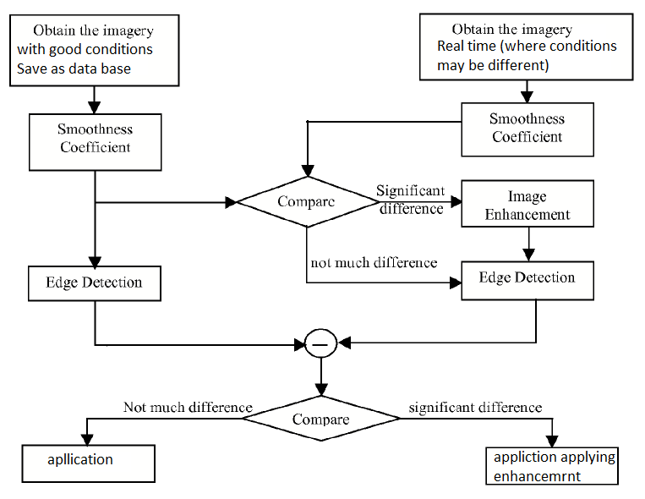

5. PERFORMANCE AND EXPERIMENTAL RESULTS:

A. Comparison of HE, CLAHE and AIVHE

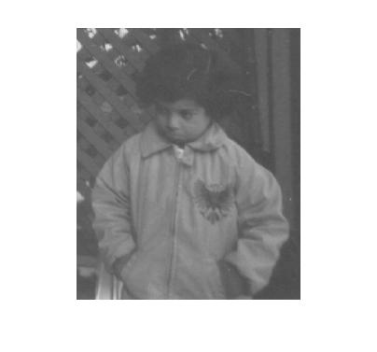 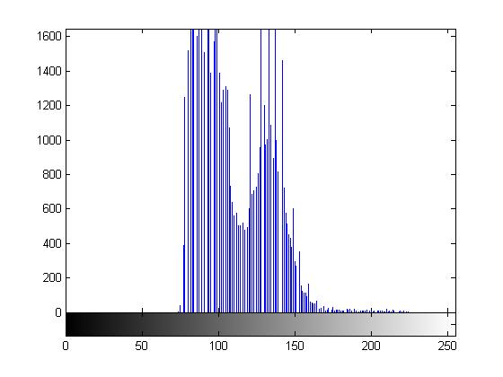

Original Image Original Histogram

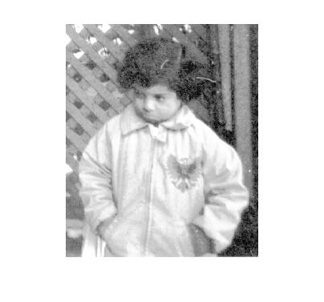 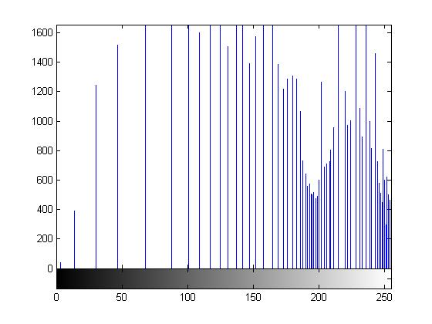

Traditional HE Traditional HE Histogram

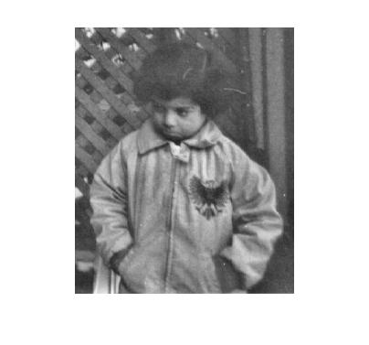 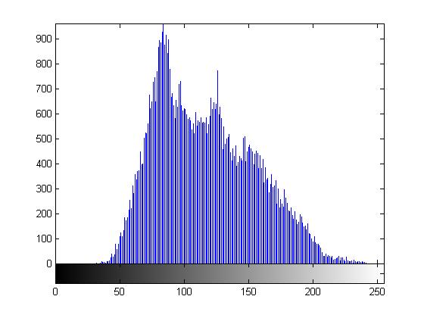

CLAHE CLAHE Histogram

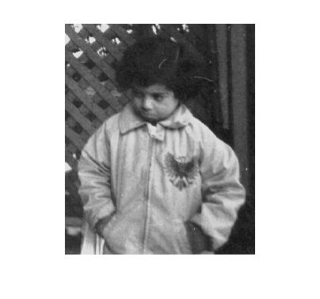 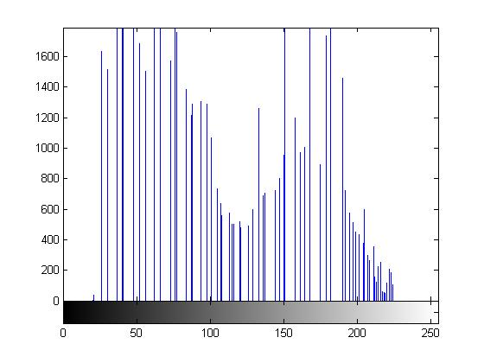

AIVHE AIVHE Histogram

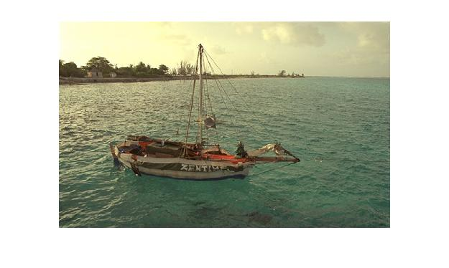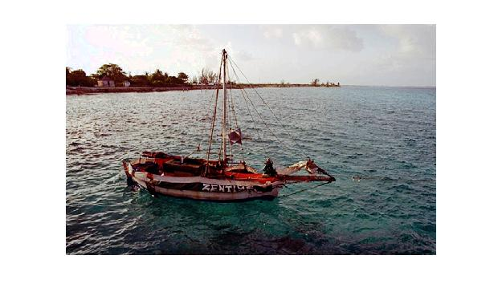

Original image Traditional HE method

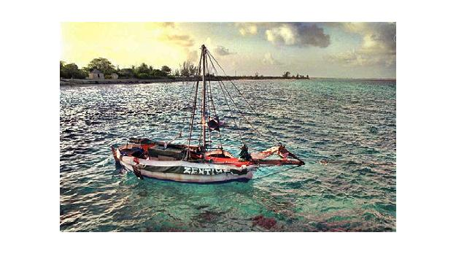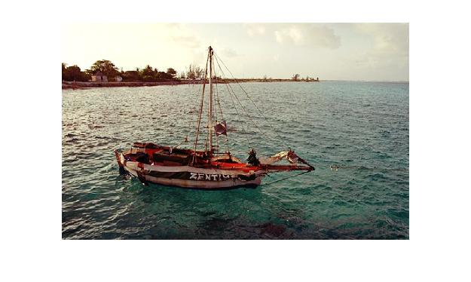

CLAHE AIVHE

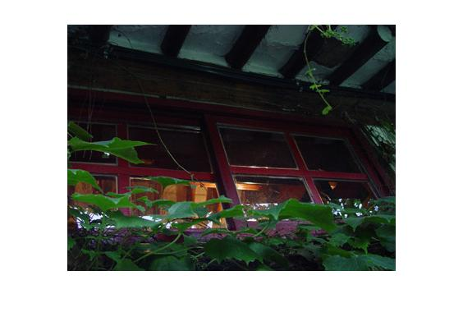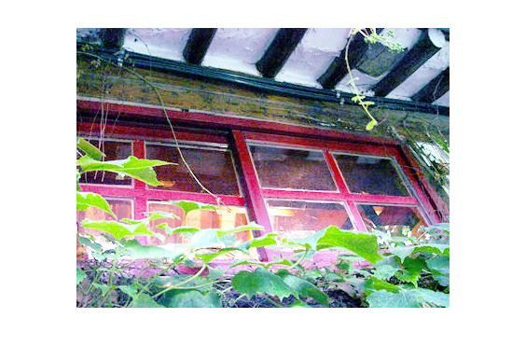

Original image Traditional HE method

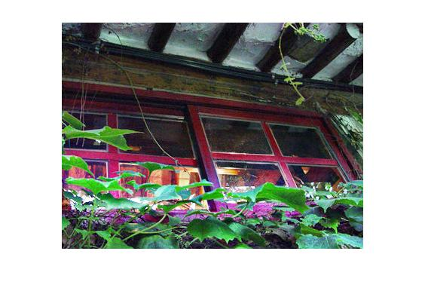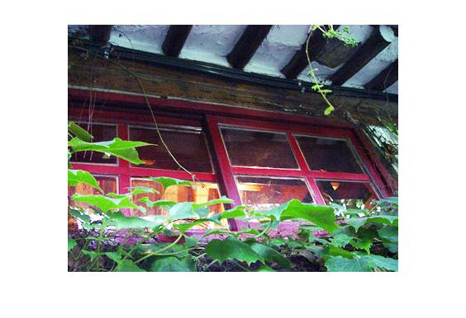

CLAHE AIVHE

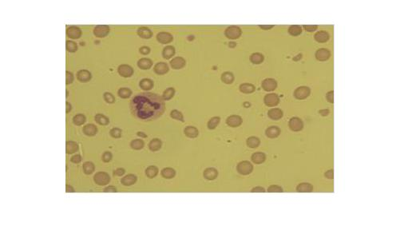 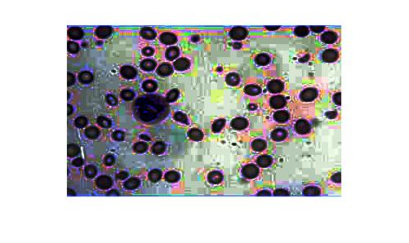

Original image Traditional HE method

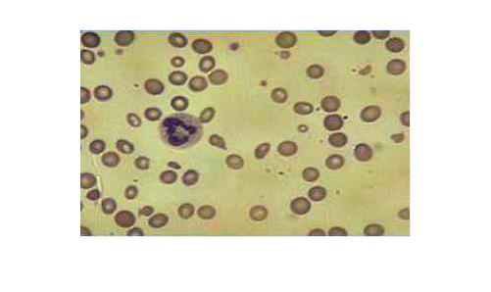 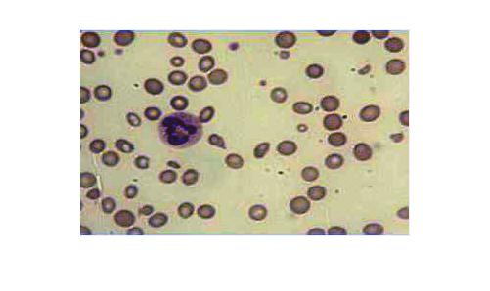

CLAHE AIVHE

B. Comparison of HE, CLAHE, AIVHE and Retinex

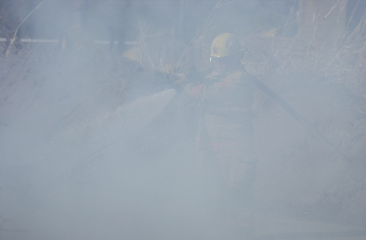 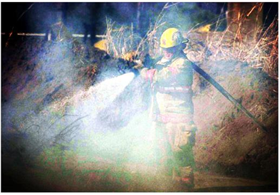

Original Image Traditional HE

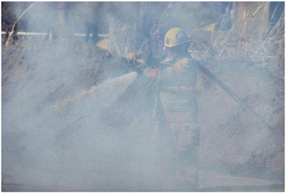 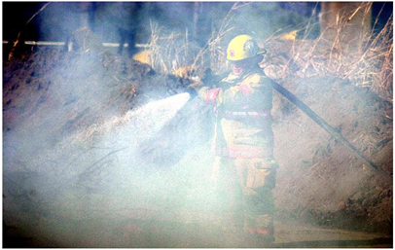

CLAHE AIVHE

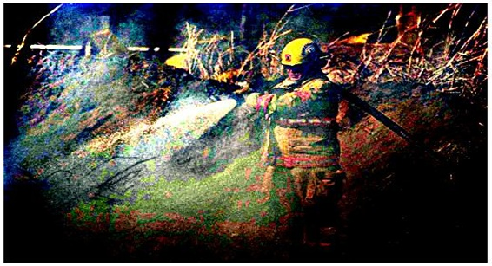

Retinex

Graphs shown below are the variation of mean and standard deviation w.r.t gamma (*γ*) and beta (*β*). Mean and standard deviation are plotted for fig

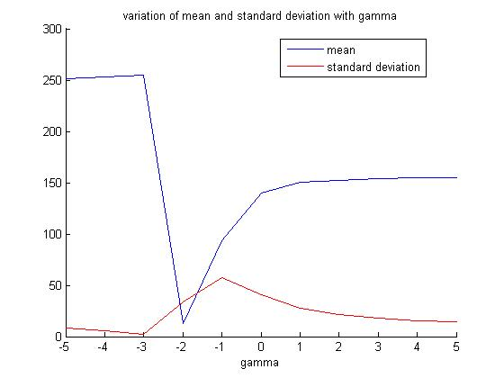

Figure.Variationof mean and standard deviation to gamma(*γ*)

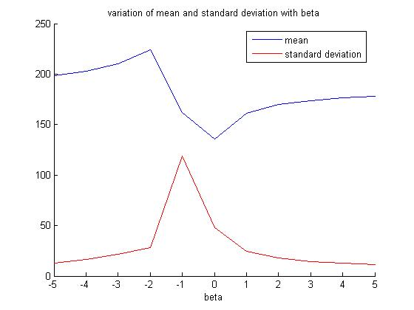

Figure . Variation of mean and standard deviation to beta (*β*).

C. Comparison of Traditional Canny, Adaptive Canny and SUSAN Edge Detection

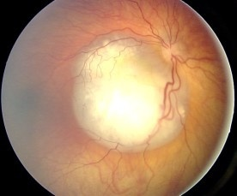 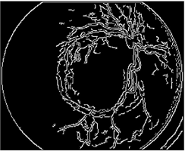

Original Image Traditional Canny Edge

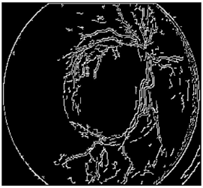 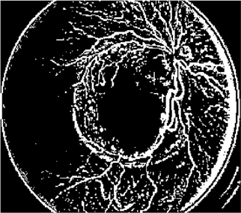

Adaptive Canny Edge SUSAN Edge

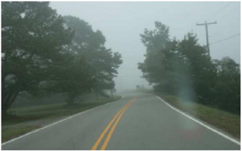 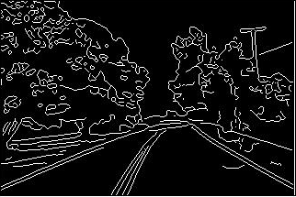

Original Image Traditional Canny Edge

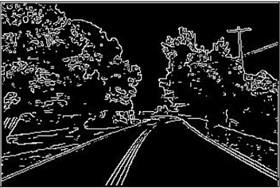 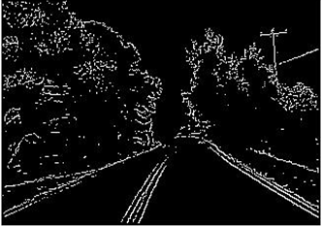

Adaptive Canny Edge SUSAN Edge

*Software used for Simulation and Performance evaluation is MATLAB*

In our project, we propose a system capable to perform segmentation of images in an automatic / unsupervised way. No prior assumptions whatsoever are made about the image (type, features, contents, stochastic model, etc.). Such an “universal” algorithm is most useful for applications that are supposed to work with different (and possibly initially unknown) types of images (e.g., searching for images on the Internet or in the photo archive of a magazine). The proposed system can be readily employed, “as is,” or as a basic building block by a more sophisticated image segmentation algorithm (that incorporates additional “knowledge” into different parts of the system).

6. CONCLUSION:

1. Adaptive median filter preserves fine detail and smooth non-impulsive noise and does not erode away edges. Normal median filter cannot remove noise greater than 0.4 density but adaptive median filter can do so.
2. Smoothness coefficient decreases as image enhancement quality gets better.
3. AIVHE and Retinex both give better results and considering subjective criteria AIVHE gives best enhancement result. AIVHE is more Universal enhancement technique.
4. Compared to traditional operators, adaptive edge detection gives clear and better edges without false edge and sets parameters according to image features.
5. Susan Edge detection gives better performance in presence of noise and provides good edge, connectivity, better localization and no false edges compare to other derivative based operators.

7.REFERENCES:

[1] Peng Hui, Zhai Ruifang, Liu Shanmei, Wen Youxian, Wu Lanlan, Edge Detection of Growing Citrus Based on Self-adaptive Canny Operator 2011.

[2] Li Er-sen, Zhu Shu-long, Zhu Bao-shan, Zhao Yong, Xia Chao-gui, Song Li-hua An Adaptive Edge-detection method based on Canny Operator, 2009.

[3] Sifeng Wang, Jingxiu Zhao, A Self-Adaptive Edge Detection Method Based on LoG Algorithm, 2008.

[4] Ching-Hsi Lu, Hong-Yang Hsu and Lei Wang, A New Contrast Enhancement Technique by

Adaptively Increasing the Value of Histogram, and A New Contrast Enhancement Technique Implemented on FPGA for Real Time Image Processing.

[5] Zhong Zhang , Geng Zhao Xi`Dian University,2011 IEEE, Beijing Electronic Science and Technology Institute

[6] Chunxi Ma, Lei Yang, Wenshuo GAO, Zhonghui Liu Digital Media Department. Communication University of China, ICMEE2010, Beijing,China ,2010 2nd International Conference on Mechanical and Electronics Engineering.

[7] Zahraa Elhassan M. Osman1, Fawnizu Azmadi Hussin, and Noohul Basheer Zain Ali, Electronic Engineering Department, Universiti Teknologi PETRONAS

[8]. Li Er-sen Surveying and mapping institute Information and engineering university, IAEU

Zhengzhou, China,2009 .

[9].Rafael Gonzalez and Richard Woods,Digital Image Processing.

[10]. Wenshuo Gao, Lei Yang, Xiaoguang Zhang, Bin ,Zhou Chunxi MaInformation Engineering School of Communication University of China,2010 2nd International Conference on Education Technology and Computer (ICETC)

[11]. Yan Shijiang, Nanjing, China, Tang Guoan,Key laboratory of Virtual Geographic, Environment Ministry of Education

[12]. Zhen Zhang , PeiYing Zhang, Zhou Yu School of Electrical Engineering, Zhengzhou, University Zhengzhou 450001, China,2010

[13]. Jianxia Wang, Guilong Gao Huili Yang, College of Information Science & Engineering, Hebei University of Science and Technology.